INTERNATIONAL FOURSOME CHAMPIONSHIP SENIOR LADIES
8 - 10 APRIL 2026

Royal Golf Club de Belgique
« RAVENSTEIN »
https://www.rgcb.be/

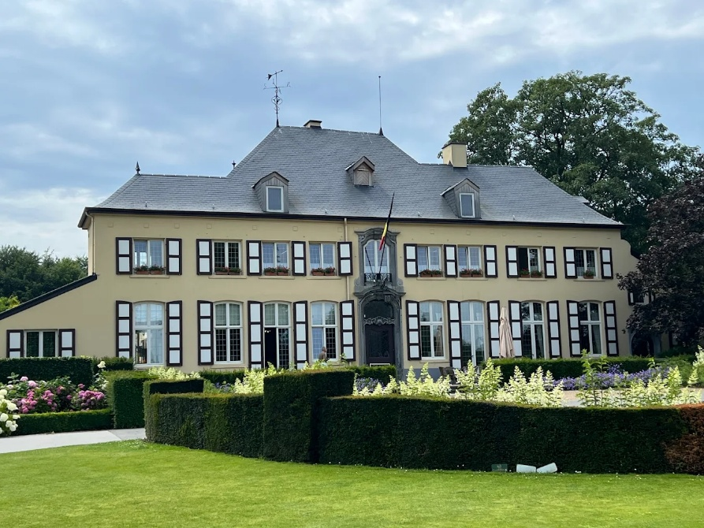

Dear Friends,

We have the pleasure to invite you to the International Foursome Championship Senior Ladies 202, that will take place at the Royal Golf Club Belgium from 8 to 10 April 2026.

CONDITIONS :

The championship is open to all amateur women golfers who are members of a recognized Senior Golf Association and who possess a certified handicap.

SERIES :

First series : the sum of the handicaps is equal to or less than 24.4
Second series : the sum of the handicaps is between 24.5 and 34.4
Index on March 22.

ENTRIES and FEE

* 480€ / team
* 60€ pp for the diner on Wednesday (optional) (apéritif, water and wine include)
* 25€ pp for the lunch on Friday (optional)

Entries must reach the office of the A.G.S.D.B. secretariat.agsdb@gmail.com
before March 22 2026

Game Formula

1st SERIES: 8 and 9 april –Stroke Play –18 holes. Qualifications.
10 april - Stroke Play –18 holes. Cut (brut): 50% teams and ex- æquo . Min.12 flights.

2d SERIES : 8 and 9 april 2026 - Stableford – 18 holes. Qualifications.
10 april - Stableford – 18 holes. Cut (brut) : 50% teams and ex- æquo . Min.12 flights.

THROUGHOUT THE CHAMPIONSHIP THE ORDER OF DRIVING EACH DAY MAY NOT
ALTERNATE. PLAYERS ARE ENGAGED FOR THE 3 TOURNAMENT DAYS.

BUGGYS ARE NOT ALLOWED

For the non-qualified players, a single competition will be held on the 9 hole course “New Course”

PROGRAM

7 april : If you want to recognize the course please contact the club au +32.2.767.43.40 or by email at info@rgcb.be Green-fee : 80€.

8 april : 1st day qualification. In the evening, aperitif and diner at the clubhouse (optional, to be paid in advance) Dress code : club or association uniform.

9 april : 2d day qualification. Free evening.

10 april : After cut, starts from hole 1 (1st series) and hole 10 (2d series) for the last day.
For the non-qualified players, a single competition will be held on the 9 hole course “New Course)
Prize giving after competition. Your presence will be appreciated around 3.30pm
2 brut prices and 1 net price in each series.
The lunch will be served upon arrival.

The organizers retain the right to make alterations to the conditions without notification.
The organizers decline any responsibility in case of cancellation of the competition due to
circumstances beyond their control, for example weather conditions.

The final ranking will be established using the tiebreaker (3rd round cards) on 9, 6, 3 and the last hole, then if the tie remains, hole by hole going up. If still tied, we will take the card from the 2nd round.

Accomodation

We do not have any agreement with hotels but we can provide you with 3 addresses near the golf course. These 3 hotels are located less than 15 minutes from the golf course.

Hôtel Rastelli *** à Tervueren : https://hotelrastelli.be/
Hôtel Mix**** à Auderghem : https://mix.brussels/
Hôtel Panorama*** à Overijse : https://www.hotelpanorama.be/

We look forward to welcoming you on April 9th.

Le Comité AGSDB

ENTRY FORM
FOURSOME INTERNATIONAL 2026

Player 1 :

Name and first name :

Nationality : mail :

Handicap/index

Player 2

Name and first name :

Nationality : mail

Handicap/index

Diner 60€ per person x 60€ ………………
Lunch 25€ per person x 25€ ………………
Inscription : 480€

To be paid on account l’AGSDB
Rue du Chêne au Corbeau, 2
1380 Lasne - Belgium ……………….
IBAN BE68 2200 3312 5334
BIC GEBABEBB
Please be sure the amount is correct in euro.

